Smart EV Charging Optimization with Geo-Analytics

# Project Overview

Title of the Project: Smart EV Charging Optimization with Geo-Analytics  
Team Name: Innovators  
Participants: Shikhar Verma , Sanket Raj Chauhan , Pooja.

Contact: 7355354823,7766063202,6376262176

College:- University Of Engineering and Management, Jaipur

# Problem Statement

The rise of electric vehicles (EVs) in urban areas is hindered by inefficient charging station placement. Poor accessibility leads to underutilized stations, slows EV adoption, and hampers urban sustainability goals. This creates an urgent need for an optimized EV charging network to support clean transportation.

# Solution Description

Our AI-driven solution optimizes EV charging station placement using machine learning and geospatial data analysis. By clustering current EV station locations and predicting high-demand areas, we ensure stations are placed where they are most needed.  
  
Core Innovation: A unique blend of AI and urban analytics, addressing a real-world problem. The solution leverages K-Means clustering and linear regression models to generate precise, scalable infrastructure plans, ensuring EV charging stations are effectively placed for maximum usage.

# Technical Architecture

- AI Algorithms/Models: K-Means Clustering, Linear Regression  
- Datasets: EV Charging Station Data, Population Density Data  
- Programming Languages: Python, HTML, CSS  
- Tools: Flask, scikit-learn, OSMnx, Folium, Pandas, NumPy

# Social, Ecological, and Economic Impact

Environmental Impact: Optimizing EV infrastructure could lead to a 20% reduction in carbon emissions by promoting EV adoption in urban areas. Economic Impact: Savings in fuel costs and job creation in the EV infrastructure sector. Social Impact: Improved air quality and public health, reduced congestion, and increased accessibility to green transportation.

# Integration with Existing Systems

Our solution integrates with existing city infrastructure and planning systems by using publicly available data like population density, road networks, and EV station locations. It complements city development plans, supporting local governments and corporations in expanding EV infrastructure efficiently.

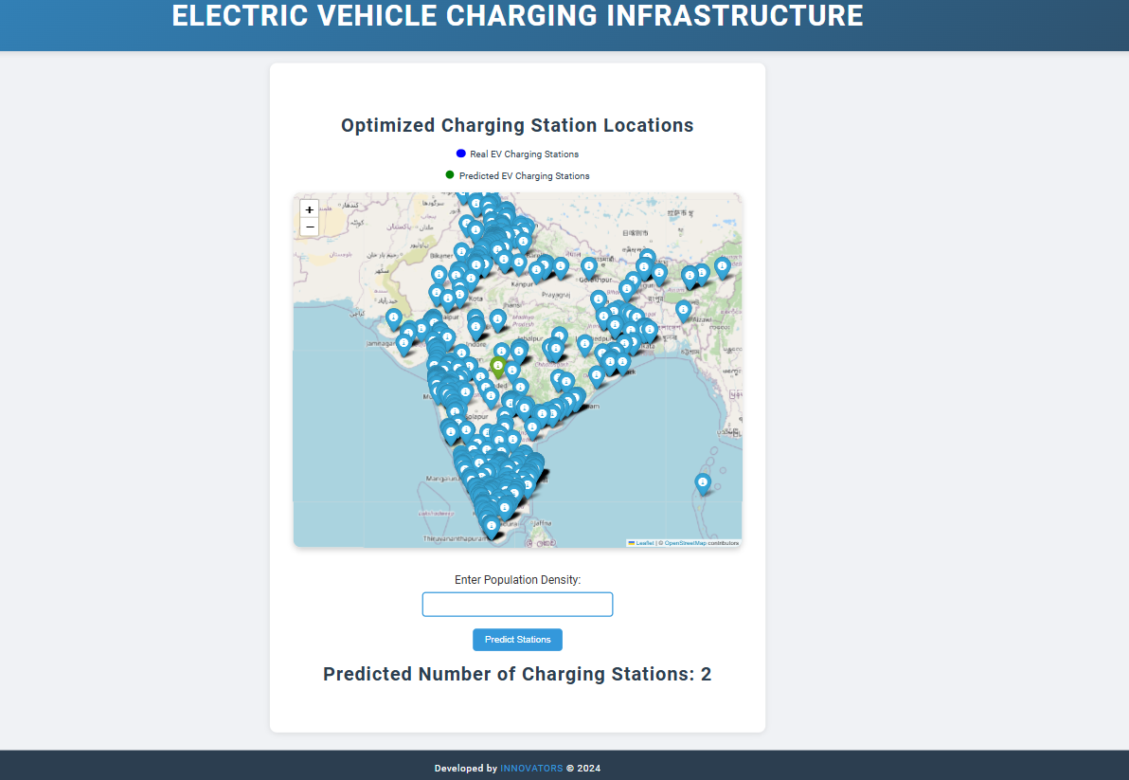

# Scalability and Real-World Deployment

The solution is scalable across any city with geospatial and demographic data. It can be easily integrated into smart city projects, making it ideal for large metropolitan areas or smaller cities aiming to enhance sustainable mobility.

# Market Opportunity

As EV demand rises globally, governments and corporations are investing heavily in charging infrastructure. Our AI-driven solution optimizes these investments, ensuring efficient, cost-effective deployment of EV charging networks to meet future demand.